Student Groups
Protocol and Business Process Guidelines

Revision Date: 09/15/2010
P:\SA\Functional\Campus Community\Student Group Policy Document.doc
Introduction

This document provides users of Student Group functionality guidelines for maintaining students groups including responsibilities/expectations and commonly asked questions.

Prerequisites/Assumptions

Before you can use the PeopleSoft Student Administration system to maintain a Student Group, it is assumed that each of the following conditions has been met:

- You have the necessary User ID and security access to the Student Administration system.
- Your request for the creation of a Student Group has been reviewed and approved.
- Your Student Group has been created in the student system.
- You have a general working knowledge of PeopleSoft navigation and terminology associated with Student Groups.

If You Need Further Assistance

When you apply the information found in this document, you may have further questions. Please visit http:/www.umbc.edu/sa for the latest information regarding end-user support.

Responsibilities/Expectations

A well-maintained Student Group presents numerous opportunities to use the Student Group for business processing as well as for reporting and data analyses purposes. As such, it is imperative that student groups be kept up to date and accurate. Once you have had a Student Group approved and created, there are several guidelines that should be followed:

- Student groups should be maintained. For groups that are cohort based i.e. UMBC Scholars Programs, it is expected that updates for a semester will be completed by the 10th day of each semester. Non-cohort based groups such as Pre-Medicine and Pre-Dentistry should be updated as soon as feasible once student’s group status has changed.
- At least one staff member will be designated as the Student Group manager. This staff person will ultimately be responsible for group maintenance and integrity.
- Report Exchange (REX) reports should not be used for official UMBC reporting.
- Rex data should not be shared with other offices or external constituents without consulting with the respective Student Group manager.

Common Questions

- What are student groups?
Enables tracking of students within a group for data analyses purposes or for campus-wide processing, such as billing, academic advising, or financial aid awarding. Examples: Young Scholars, Meyerhoff Scholars, Athletes, Pre-Medicine, Transfer Student Alliance, etc.

- How do I request a student group?

You can request a student groups through RT Help link via myUMBC. After receiving your request, a meeting will be scheduled with you to discuss your needs. This is done to assure that a Student Groupis the appropriate tool to accomplish your goals.

- Who should go in the group?

Who goes into your group depends on the population you are attempting to track. In many cases, groups are related to admit term, so new additions and inactivations are made each semester or academic year e.g. UMBC Scholars Programs. To allow for yield tracking and analysis, cohort-based student groups such as the UMBC Scholars Programs should be assigned to all students offered the scholarship not just those accepting the award.

If the group is non-term based e.g. Pre-Medicine, Pre-Veterinary or Pre-Dentistry, these groups are usually more fluid and are updated on an ad-hoc basis.

- Should group members be inactivated or deleted?

In general, group members should be inactivated using the Status field. Examples of students who should be inactivated are:
  - Students assigned to a Student Group and then subsequently do not matriculate
  - Students no longer eligible or participating in the program
  - Students who discontinue their enrollment or graduate
When inactivating a student from a student group, users may opt to use the comment field to detail the reason(s) the student has been inactivated.

The effective date of the inactivation is important. Report Exchange looks at the date of the inactivation to determine whether a student is listed in Student Group related reports for a particular semester. For example, a student who is inactivated after the start of the Fall semester will be counted in the Fall semester statistics for reporting purposes.

If you want to track yield from admission to the university to enrollment, the effective date of the inactivation row must be after the start of classes for the semester in which they were admitted.

As a Student Group manager, you have the ability to either back date or future date inactivation rows, this functionality can be used to help manage whether and in what semesters a student will appear in your Student Group reporting.

In cases where a student has been added to a group in error, they should be deleted from the group.

- How should program affiliates be tracked with student groups?

Some programs such as the UMBC Scholars Programs include students who are associated with the group but receive no funding. We are exploring the possibility of adding a status reason that will allow tracking of funded v. unfunded program members. In the meantime, we recommend you assign the Student Group to the affiliate members and include a comment indicating their non-funded status.

- What are the options regarding reporting?

REX (Reporting Exchange) is the tool of choice for report generation at UMBC. REX allows for reporting on a broad range of admissions, enrollment, retention and graduation indicators by student groups. To request REX access and training submit a RT ticket via myUMBC.

- How do I access my student group?

To maintain your group, you access your Student Group via screens available in our student information system (PeopleSoft). You will be provided specific navigation and screen content training once your group has been created. You will also be able to access Student Group related reporting in REX.

- How do I request access for additional staff members?

The most effective way is to enter a ticket into RT with the staff member’s name, department, campus ID or myUMBC ID, and to which group the staff member requires access.

- Can students be mass assigned into my student group?

Yes, but there is additional work required for this to occur. This is best done for groups that have definable criteria for entry into the group such as the UMBC Scholars Programs.

1.0 Student Group Maintenance

Each PeopleSoft user who has access to maintain their assigned Student Group, will have the ability to add, delete, modify or review Student Groups for individual students.

The following tasks are associated with maintaining a Student Group

1.1 Searching for a Student
1.2 Add a new Student Group to a student’s record
1.3 Inactivate a student from a Student Group

  - Searching for a Student
Navigation: Records and Enrollment>Career and Program information>Student Groups

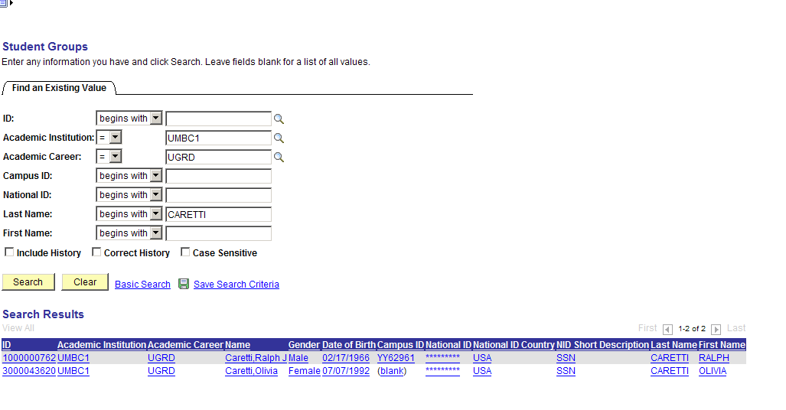

Step 1
Enter the Student ID or Campus ID.
If unknown;
Enter the Last Name – if the last name is extremely long, you may type a partial last name.
Enter the First Name

Step 2
Click the button.

Step 3
If the selected student is already assigned to one or more student groups, the Search Results will display multiple listings for the student as shown above. Simply click on the Student Grouprecord you wish to view.

Note: If a staff member does not have security access to view the Student Groupto which the student is assigned, the Search Results will display a message of “no matching values were found.”

  - Add a new Student Group to a student’s record
Navigation: Records and Enrollment>Career and Program information>Student Groups

As in section 1.1 above, you can search for a student via emplid, name, campus id, or national id (ssn). If you enter a criteria that is specific to only one student (i.e. ssn), that student’s information is displayed on the “Students Groups” screen below.

If there are multiple students for the criteria entered, you will see a list (directly below).

If you click on id 1000000762, the screen below will be displayed:

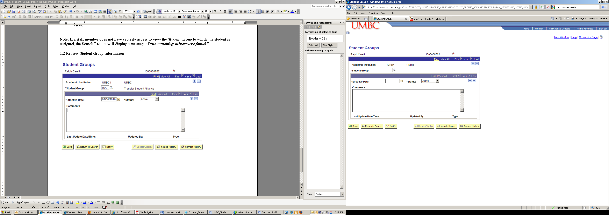

Note: In the case above, this person does not have any student groups on their record, or you do not have security access to groups to which the person belongs.

To add a Student Group to the student selected:

Step 1
Select a Student Group to add via the icon.

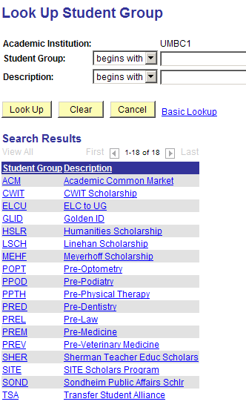

Step 2
Select the Student Group desired.

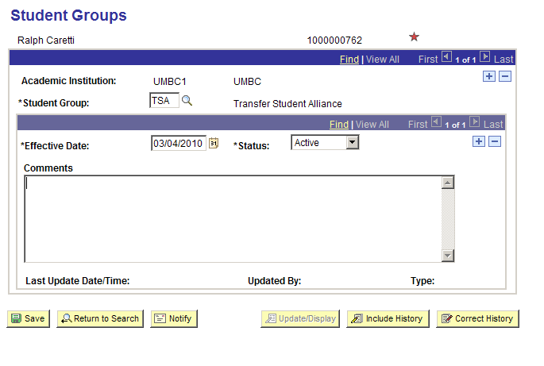

Step 3
The system assigns an effective Date and Status. You can change this date if desired.
Step 4
A status of Active means the student is active in the group. A status of Inactive signifies a student that was once in the group but is not currently a member of the group.
Step 5
Enter comments if desired.
Step 6
Click

1.3 Inactivate a Student in a Student Group
Navigation: Records and Enrollment>Career and Program information>Student Groups

Step 1
To inactivate a student from a Student Group, first look up the student in the Student Groups Page and then click the 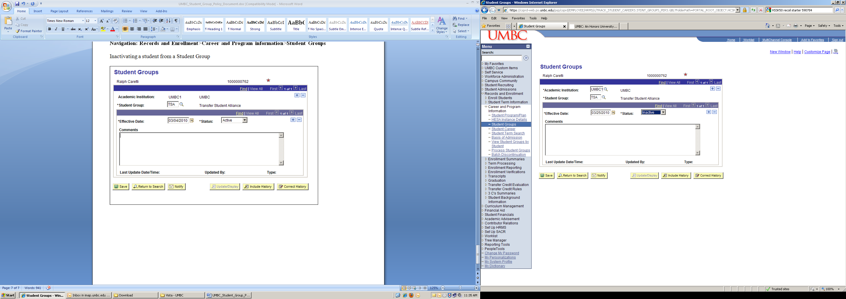 icon as highlighted below.

Step 2
After clicking the icon, select the Status value of Inactive.

Step 3
Click

